RAG Chain Architecture –
"Imagine I give an AI a 500-page company document and ask it one simple question: 'What is the leave policy?' Will the AI read the entire 500 pages every time?"
Obviously, that would be slow and unnecessary.
"So, how can we make the AI smart enough to find only the information it needs and then answer our question?"
That's where RAG comes in.
RAG stands for Retrieval-Augmented Generation.
In very simple words:
RAG means: First find the right information, then give that information to the AI, and finally let the AI generate the answer.

RAG Chain Architecture
We can imagine RAG as a smart librarian
Suppose I go to a library and ask:
"Where can I find information about annual leave?"
The librarian doesn't give me the entire library.
Instead, the librarian:
- Understands my question
- Finds the relevant book/page
- Gives me that information
- I use that information to get my answer
RAG works in almost the same way.
The complete flow is:
Documents
↓
Chunking
↓
Embeddings
↓
Vector Database
↓
User Question
↓
Similarity Search
↓
Relevant Context
↓
Context Injection
↓
Gemini
↓
Formatted Answer + Citations
Now let's understand each step.

Documents
First, we need to give our system some knowledge.
These can be:
- PDF files
- Word documents
- TXT files
- Websites
- Company policies
- Product information
Example:
Imagine I have a company document called:
Employee_Handbook.pdf
It contains information about:
Leave, salary, working hours, holidays, insurance, etc.
This is our knowledge source.
You can say:
"The document is like our textbook. It contains all the information that our AI needs to answer questions."

Chunking
Now we have a problem.
Our document could be 100 or 500 pages long.
Giving the entire document to the AI every time is not efficient.
So we break the document into smaller pieces.
This process is called chunking.
Example:
Instead of one huge document:
Employee Handbook
500 pages
we divide it:
Chunk 1 → Company Introduction
Chunk 2 → Working Hours
Chunk 3 → Leave Policy
Chunk 4 → Salary Policy
Chunk 5 → Holidays
...
Think of it like cutting a large pizza into smaller slices
"We don't give the AI the whole pizza. We give it only the slice it needs."

Embeddings
Now comes an interesting part.
Computers don't understand the meaning of text the way humans do.
So we convert each chunk into a vector, which is basically a list of numbers.
This process is called embedding.
For example:
"Annual leave is 20 days"
↓
Embedding Model
↓
[0.21, -0.43, 0.78, ...]
These numbers represent the meaning of the text.
The important idea is:
Similar meanings produce similar vectors.
For example:
"How many vacation days do I get?"
≈
"What is the annual leave allowance?"
Even though the words are different, their meaning is similar.

Vector Database
Now we have all these vectors.
Where do we keep them?
In a vector database.
Examples include:
- PostgreSQL + pgvector
- ChromaDB
- FAISS
- Pinecone
You can think of the vector database as a smart cupboard .
It stores:
Text Chunk + Its Vector + Metadata
So later, when a user asks a question, we can quickly find the most relevant information.

Retrieval with Similarity Search
Now the user asks:
"How many vacation days can I take?"
The system converts this question into an embedding too.
Then it compares the question vector with the vectors stored in the database.
This is called similarity search.
Imagine we get:
Leave Policy → 0.94
Salary Policy → 0.31
Working Hours → 0.20
Holiday Policy → 0.15
The system says:
"The Leave Policy is most relevant to this question."
So it retrieves that chunk.
Very simply:
Similarity search means finding the stored information that is closest in meaning to the user's question.

Context Injection into Prompt
Now we have found the relevant information.
But Gemini still needs to see that information.
So we put the retrieved information into the prompt.
This is called context injection.
For example:
Context:
Employees are entitled to 20 days of annual leave per year.

Question:
How many vacation days can an employee take?

Answer based on the context.
Now Gemini has the question + relevant information.
Think of it as giving a student a small cheat sheet before an exam.
"We don't give Gemini the entire textbook. We give it the relevant page."

Generation with Gemini
Now comes the Generation stage.
This is where Gemini comes in.
Gemini receives:
Relevant Context
+
User Question
↓
Gemini
↓
Final Answer
For example:
Question:
How many vacation days can an employee take?
Context:
Employees are entitled to 20 days of annual leave per year.
Gemini generates:
"Employees are entitled to 20 days of annual leave per year."
So remember:
Retriever finds the information. Gemini uses that information to generate the answer.

Handling Context Window Limits
Now imagine we retrieve 100 pages of information.
Should we send all 100 pages to Gemini?
No.
Every AI model has a context window, which means there is a limit to how much information it can process in one request.
Think about your school bag .
If you put 50 books inside it, eventually there won't be enough space.
The same idea applies to the AI.
So we manage it by:
1. Using appropriate chunk sizes
Break large information into manageable pieces.
2. Retrieving only relevant chunks
Don't retrieve everything.
3. Using Top-K retrieval
For example, retrieve the top 3 or 5 relevant chunks.
4. Summarizing when necessary
If the retrieved information is still too large, summarize it.
Simple idea:
"Don't give Gemini the whole library. Give it only the few pages needed to answer the question."

Response Formatting
Gemini may generate the correct information, but we also want the answer to be easy to read.
Instead of:
employees can take 20 days leave every year and should request it in advance
we can format it as:
Annual Leave Policy
- Employees can take 20 days of annual leave per year.
- Leave should be requested in advance.
This makes the response much easier for the user to understand.

Citations
Finally, we want the user to know:
"Where did this answer come from?"
That's where citations come in.
For example:
Employees can take 20 days of annual leave per year.
Source: Employee_Handbook.pdf, Page 5
This is useful because the user can verify the information.
So:
Formatting makes the answer easy to read. Citations make the answer easier to trust and verify.

"Let's imagine I have a 500-page company handbook."
First, I load the document.
Then I break it into smaller chunks.
I convert those chunks into embeddings, which are numerical representations of their meaning.
I store those embeddings in a vector database.
Now an employee asks:
"How many annual leave days do I get?"
The question is converted into an embedding, and similarity search finds the most relevant chunk from the database.
That relevant information is then injected into the prompt as context.
Gemini receives the question and the retrieved context and generates the answer.
If the retrieved information is too large, we manage the context window by limiting the number of chunks or summarizing them.
Finally, we format the answer clearly and provide citations showing where the information came from.
"RAG is basically a smart librarian: it finds the right information, gives it to Gemini, and Gemini turns that information into a clear and useful answer."
That's the complete RAG chain architecture.

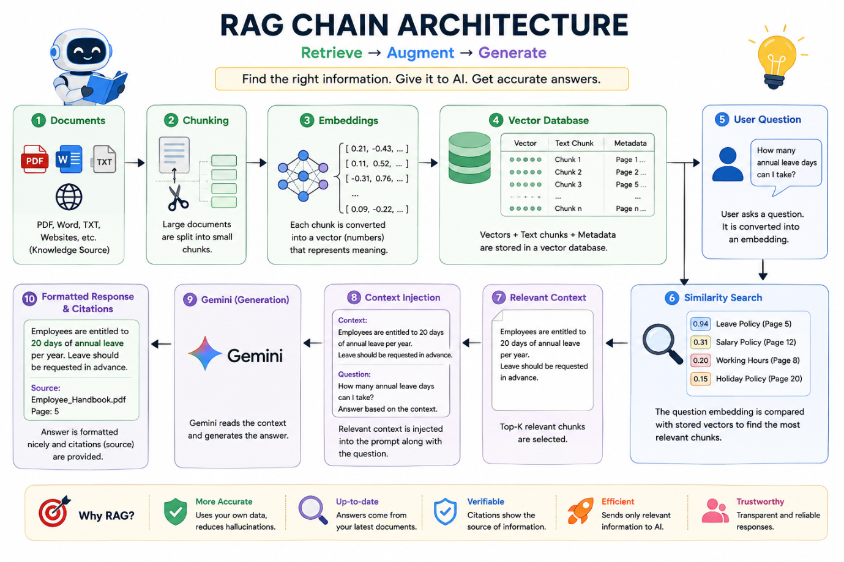

Hands-On: Complete naive RAG system for banking FAQs

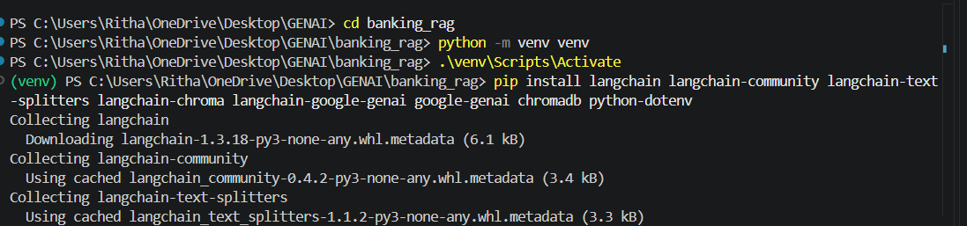

Inside banking_rag, create these files.
banking_faq.txt
rag.py
.env
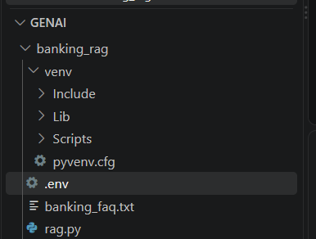

Open banking_faq.txt and paste this:

Banking FAQs

Q: What is the minimum balance required?

A: Savings accounts generally require a minimum balance of Rs. 5,000.

Q: How can I reset my ATM PIN?

A: Customers can reset their ATM PIN using the bank mobile application or by visiting an ATM and selecting the PIN change option.

Q: What should I do if my debit card is lost?

A: Immediately block the debit card using the mobile banking application or contact customer support.

Q: What is the ATM withdrawal limit?

A: The daily ATM withdrawal limit depends on the customer's card type. Customers should check their card-specific limit.

Q: What documents are required to open a savings account?

A: Customers generally need identity proof, address proof, and a recent passport-size photograph.
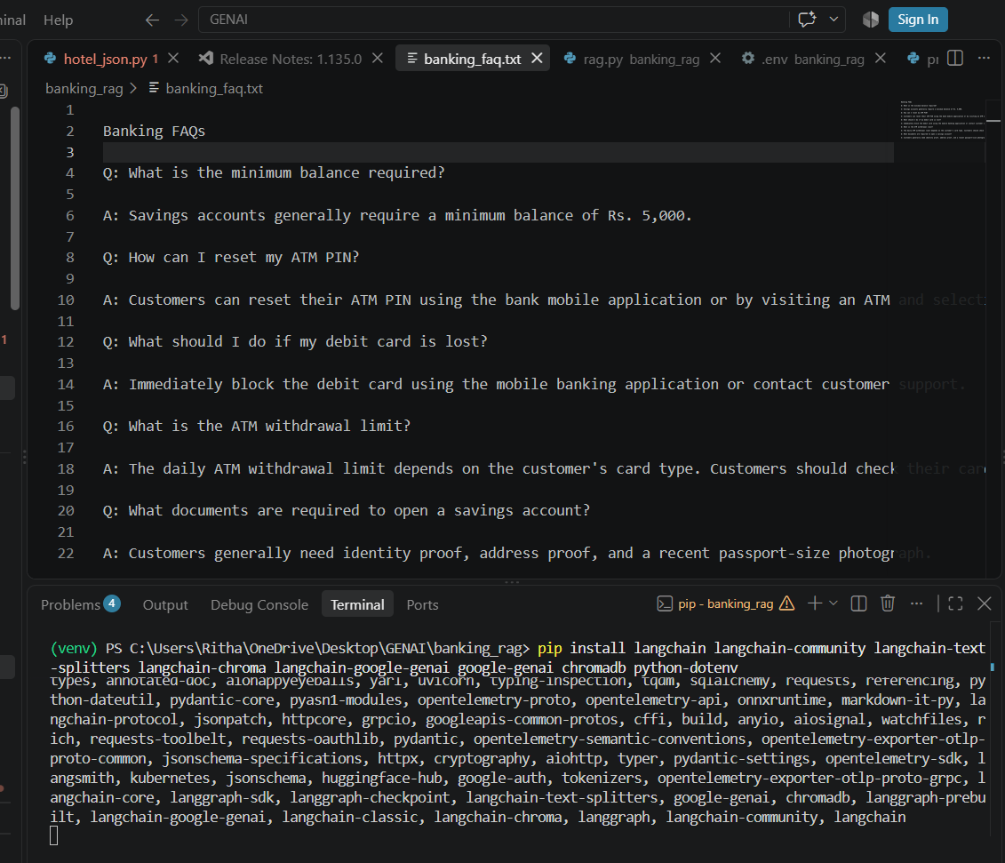

Open .env
Paste:
GOOGLE_API_KEY=your_gemini_api_key_here
Open rag.py
from dotenv import load_dotenv
load_dotenv()

from langchain_core.documents import Document
from langchain_text_splitters import RecursiveCharacterTextSplitter
from langchain_google_genai import GoogleGenerativeAIEmbeddings
from langchain_chroma import Chroma
from google import genai

# --------------------------------------------------
# 1. LOAD BANKING FAQ DOCUMENT
# --------------------------------------------------

with open("banking_faq.txt", "r", encoding="utf-8") as file:
text = file.read()

print("Document loaded successfully!")

# Convert text into a LangChain Document
document = Document(page_content=text)

# --------------------------------------------------
# 2. SPLIT DOCUMENT INTO CHUNKS
# --------------------------------------------------

splitter = RecursiveCharacterTextSplitter(
chunk_size=300,
chunk_overlap=30
)

chunks = splitter.split_documents([document])

print("Document split into chunks!")
print("Number of chunks:", len(chunks))

# --------------------------------------------------
# 3. CREATE EMBEDDINGS
# --------------------------------------------------

embeddings = GoogleGenerativeAIEmbeddings(
model="models/gemini-embedding-001"
)

print("Embedding model created successfully!")

# --------------------------------------------------
# 4. STORE DOCUMENTS IN CHROMA VECTOR DATABASE
# --------------------------------------------------

vectorstore = Chroma.from_documents(
documents=chunks,
embedding=embeddings,
collection_name="banking_faq"
)

print("Documents stored in ChromaDB successfully!")

# --------------------------------------------------
# 5. GET USER QUESTION
# --------------------------------------------------

question = input("\nAsk your banking question: ")

# --------------------------------------------------
# 6. RETRIEVAL USING SIMILARITY SEARCH
# --------------------------------------------------

results = vectorstore.similarity_search(
question,
k=2
)

print("\nRelevant information retrieved:")
print("--------------------------------")

for i, result in enumerate(results, start=1):
print(f"\nChunk {i}:")
print(result.page_content)

# --------------------------------------------------
# 7. CREATE CONTEXT
# --------------------------------------------------

context = "\n\n".join(
result.page_content
for result in results
)

# --------------------------------------------------
# 8. INJECT CONTEXT INTO PROMPT
# --------------------------------------------------

prompt = f"""
You are a helpful banking FAQ assistant.

Answer the user's question using ONLY the information
provided in the context below.

If the answer is not available in the context,
say: "I don't have enough information in the banking FAQ."

Context:
{context}

User Question:
{question}

Give a clear and simple answer.
"""

# --------------------------------------------------
# 9. GENERATE ANSWER USING GEMINI
# --------------------------------------------------

client = genai.Client()

response = client.models.generate_content(
model="gemini-3.6-flash",
contents=prompt
)

# --------------------------------------------------
# 10. DISPLAY FINAL ANSWER
# --------------------------------------------------

print("\n===================================")
print(" FINAL ANSWER")
print("===================================")

print(response.text)

# --------------------------------------------------
# 11. DISPLAY SOURCE
# --------------------------------------------------

print("\nSource: banking_faq.txt")

